5. UI interface
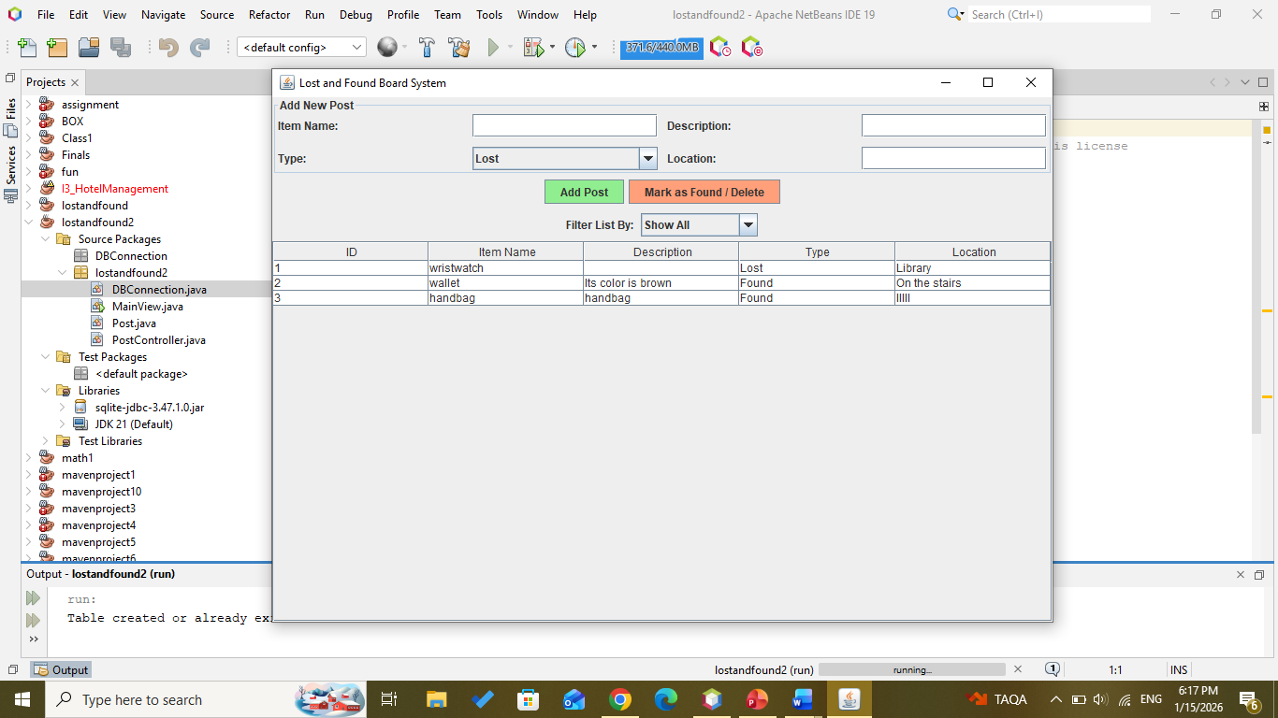
5.1Main interfase

Delete item if found Highlight the element and then press
Mark as Found/Delete
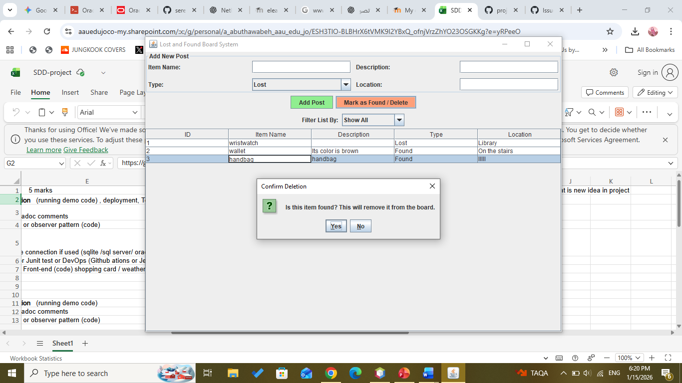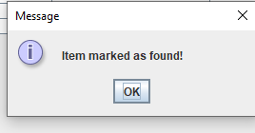
5.1 delete item
If you find or lose something, you can add a post.
Add post
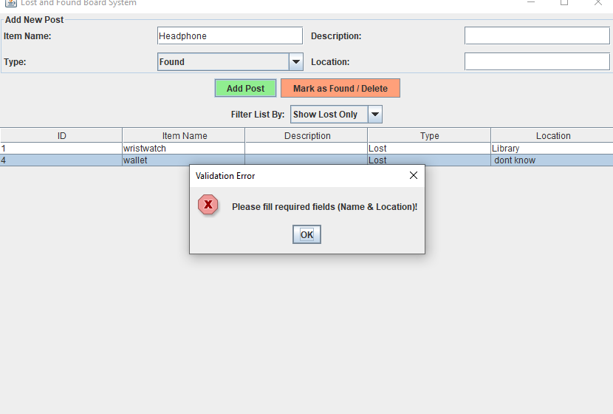
5.2 addPost

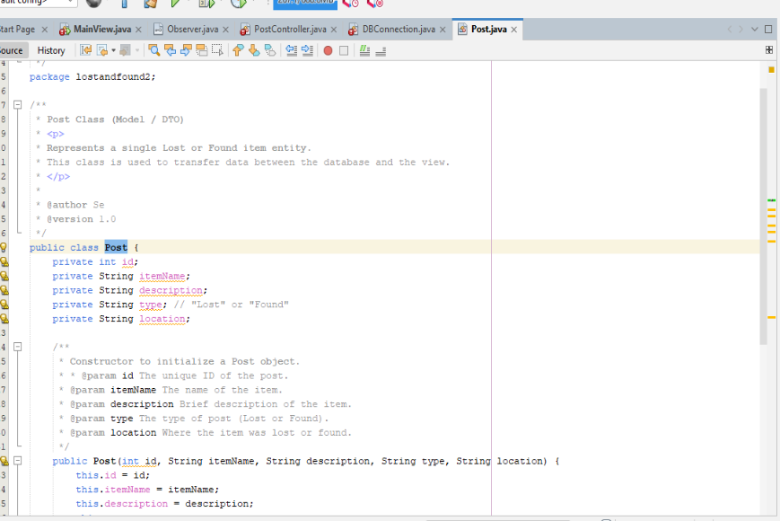
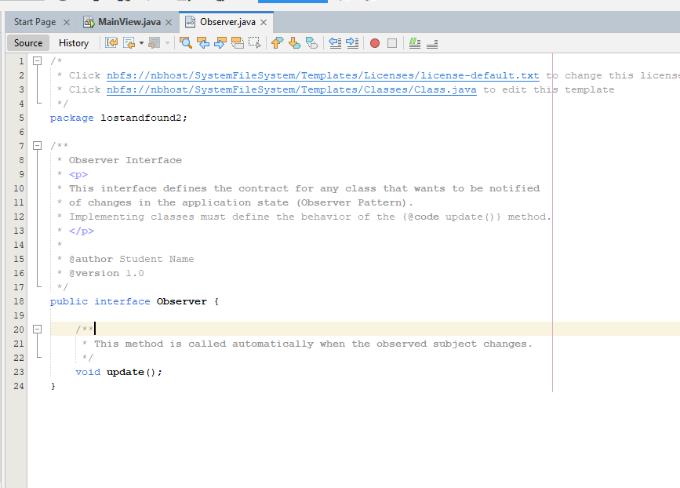
6. code: Javadoc comments

6.1 Example of Javadoc comment in Observer Interface and post interface

7. database connection used (sqlite /Libraries)
JAR: sqlite-jdbc-3.47.1.0.jar
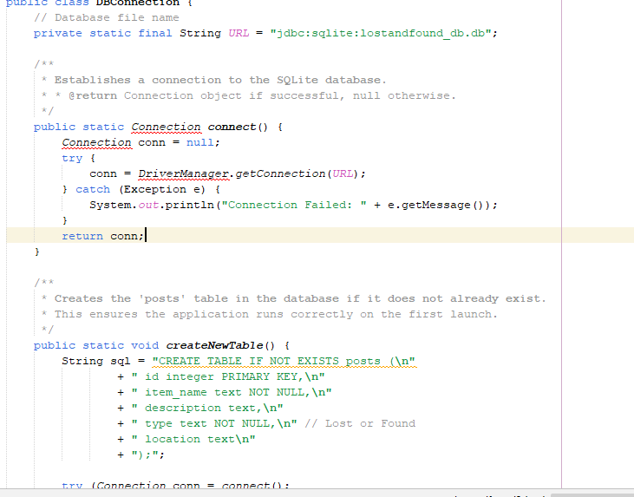
7.1 DBconiction

8. Strategy or observer pattern (code)
This diagram illustrates the implementation of the Observer Design Pattern within the system:
- The Observer: Represented by the MainView class, which implements the Observer interface. It contains the update() method, which is invoked to refresh the table data.

- The Subject: Represented by the PostController class, which is responsible for data management. It maintains a list of registered observers (List<Observer>). When a post is added or deleted, it triggers the notifyObservers() method to inform the view that the data has changed, ensuring an automatic and immediate update of the UI without manual intervention.

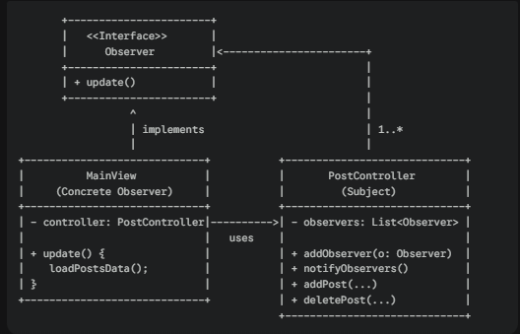
8.1Observer Design Pattern

